
Blade Server
TC4600E

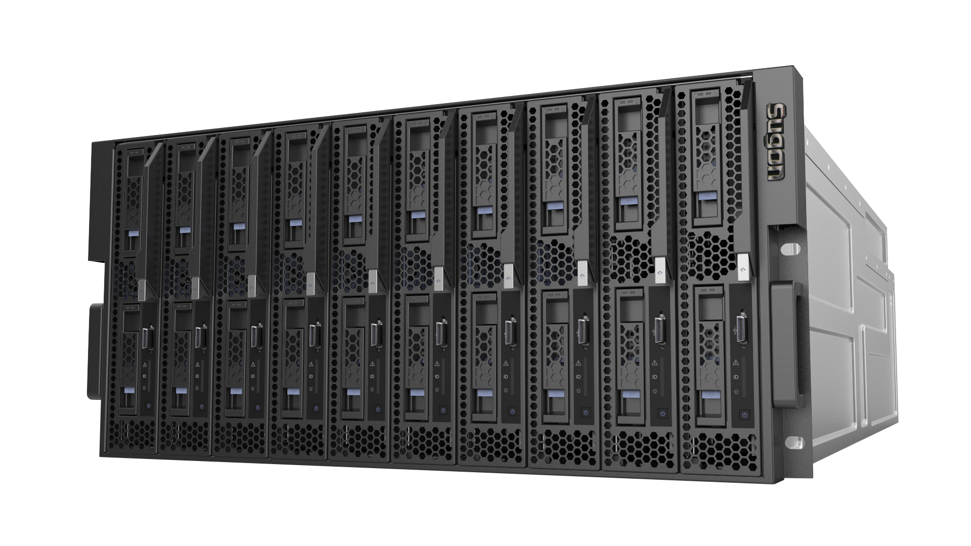

Sugon TC 4600E blade server, targeting on high-performance computing, Web infrastructure and virtualization, integrates many advanced design concepts and technical properties. It is an industry-leading server product on consistence with the standard for openness.
TC 4600E is a server of 5U and 10 blades having realized product design requirements for high performance, high density, scalability, on-demand configuration and flexible solutions to meet diverse and changeable application demands from users. Meanwhile, the product has the RAS properties of enterprise products to meet the demands of critical customers such as education, research institutions, cloud computing, security, government, oil, telecommunication, finance, meteorology, television and radio, Internet and so on.
TC 4600E blade server has excellent systematic scalability. Flexible on-demand configurations can be achieved according to actual demands. The system presently supports computing blades based on Intel E5-2600V3 processor platform: a single blade can maximum support 10 pieces of computing nodes. Through modular design, various network interfaces can be provided for computing blades: the system can support maximum 56Gb Infiniband FDR network, 1GB Ethernet network and 10Gb Ethernet. For critical components and functional modules of the system, TC 4600E adopts a redundant design realizing the enterprise RAS properties and meeting demands of critical applications.
In aspect of system management, TC-4600E provides three manners, including local BMC (IPMI), system CMM management module and large-scale cluster management software. Such a three-level overall management strategy can simplify the system deployment, operation and maintenance to the largest extent, and users can easily control the overall system.
TC4600E blade server adopts multi-level energy saving measures: the single power efficiency is up to 94%. Multi-module intelligent steam distribution measures are also applied to reduce system power consumption greatly and improve the system power efficiency and cooling efficiency. With energy saving software, the environmental protection and energy saving effects can be maximized.
TC4600E blade server is a type of high-density, high-performance blade server system independently designed by Sugon. Its open standard and interfaces completely has broken the industrial monopoly and “island”, providing the preconditions for the formation of industrial chain. Users can get more product options and complete services with reducing TCO.
Features
- Open standard
- Powerful expandability
- Convenient management
- Powerful computing ability
- On-demand configuration and scalability
- Intelligent and efficient power and cooling strategies
- Environmental protection and energy saving
Overview
In consistence with open standard
TC 4600E blade server is a high-density, high-performance blade server system independently developed by Sugon. The blade platform in consistence with the open standard can provide benefits for users from different aspects: more convenient to select components and modules by different manufacturers, protecting investments and reducing TCO.
Powerful and flexible network capability
The product provides a powerful and flexible network capability. The system supports Infiniband 56Gb FDR network, Gigabit Ethernet and 10-Gigabit 10G Ethernet, and it also provides 10G network interfaces supporting 10G network interface disk arrays and providing large-capacity disk integrated solutions, maximizing the disk system reliability to meet the demands for space saving, high-speed access and storage, protection of user data to the largest extent.
Diverse disk configuration solutions
Diverse disk expansion manners
Local disk blade can support 2 hard disks. Based on local RAID controller, RAID 0，RAID 1，RAID 1E can be established.
Convenient and overall system management
Provides local BMC (IPMI), system CMM management module and large-scale cluster management software
3-Level overall management enables users to easily control the system and the system status.
Powerful computing capability
Using Intel multi-core processor to establish high-performance computing blades and provide powerful computing capability
On-demand configuration and scalability
Users can, based on changes in business demands, dynamically adjust configurations of the blade server.
Simple, convenient, economical and efficient products upgrading can be realized.
Efficient and intelligent power strategies and cooling strategy
Automatic balancing power management maintains the power supply to work in the most efficient state at any time and minimize power consumption for users. The reasonably arranged cooling areas can maximize the cooling efficiency and reliability.
Against the dynamic changes in user applications, power supply and cooling are provided with intelligent automatic optimization policies.
Environmental protection and energy saving
Adopting advanced design concepts and multi-level energy saving measures to reduce system power consumption, improve the system power efficiency and cooling efficiency. With energy saving software, the environmental protection and energy saving effects can be maximized.

Features and advantages
Infiniband High-speed switching network
The high bandwidth, low-latency and fully interconnected high-speed Infiniband switching network provides Infiniband 4x 56Gb/s FDR connection, supporting switching between cooper cables and fiber optic connectors. The product adopts the industry-leading high-performance Infiniband switching network and the throughout of the blade case is up to 6.272Tb/s.

Functional features
Advantages
Computing blade

Providing Intel-based multi-core processors. Based on the unified infrastructure platform of Sugon TC 4600E, flexible and diverse options are provided.
Optimized selections can be made according to particular applications and different types of computing blade platforms which can satisfy various application demands are stored in the unified blade rack to obtain the best integrated overall solutions.

Standard blade chassis
5U standard rack provides 10 blade bays, standard and modular design. Network modules, management modules, computing blades from different manufacturers can be used to provide more supplying options for users; modules in different periods can be used to meet relevant standards. The product is able to prolong the life cycle of blade systems and protect investments of users.

Highly available middle plate
Passive middle plate design, free from active components, reliability is exponentially increased.
High-speed signals are designed in separation from low-speed signals, thus the reliability of the middle plate is significantly improved.
Expansion links are reserved for the faster next generation of I/O technology technology, seamless compatibility to the next generation of blade, prolong blade life cycles and protect the initial investments of users.

Ethernet
Gigabit network modules with different specifications and performances.
Regular Gigabit switching network and Gigabit switching network with Gigabit uplink to meet different application demands.
Gigabit straightforward network is applicable to meet rigorous demands of users for network performance.

Redundant design
TC 4600 power module, network module, fans module and other critical system components and modules all adopt redundant design to ensure reliable operation of the entire unit.

10G Ethernet

Supporting 10G Ethernet interfaces to satisfy bandwidth demands of high-performance computing, cloud computing and virtualization technology; providing basic guarantees, and standard interfaces for 10G storage solutions to satisfy diverse application demands of users for 10G network.

Functional features
Advantages
SRPM（Self Regulating Power Modules）

Remote KVM function

It permits to visit, install, configure and control remote blade servers from the desktop or any other place through Web browsers.
Low network bandwidth requirement eliminates geographical limitations in system managing and using of blade servers, improves the remote processing speed.
Visiting and controlling at a BIOS level and having no connection with the operating system, a complete compatibility is provided.
Highly safe data is encrypted by 128-bit digits based on hardware.

LPCM（Linear Pre-compensation Cooling Modules）

Based on temperature changes, regulate the fans rotation speed linearly and smoothly, minimizing noise level and reducing unnecessary power consumption.
Based on temperature changes, forecasting the temperature change trends in the next stage, making adjustment compensation in advanced to ensure the rotation speed of fans and the smooth noise level.

Intelligent power controller is without human intervention. Based on changes in power consumption, automatically regulate the management policy for the power system, always maintain the power module to work at the peak state of the efficiency curves, minimize unnecessary power consumption and losses, and significantly improve the life cycle of power supplies.
Supports real-time status monitoring, real-time power loads measurement and display.

FVMM（Full View Management Modules）

The Web browser-based management mode can provide detailed information about the latest status and graphics of all components.
Real-time status monitoring, faults alarm; dynamically optimizing and regulating resource allocation and working policies.
Save and implement statistical analysis on critical historical data; intuitively display the changing trends of important information.
A variety of faults alarm modes, logs, audits and reports are available for query.
Permitting remote encryption to control operations and monitor overall status from any place.
Remote KVM is permitted getting away from noisy room environment.

Remote virtual media

Providing each computing blade with remote virtual media for installing operation systems, copying documents and other operations.
Coupled with the remote KVM and Web interface management, overall remote management and control can be realized on the system.
Medium can be initiated to bring convenience for rapid installation of operating systems and data copying. 。

Functional features
Advantages
OPSI (Optical Path Status indicator)

The optical path status indicator covering various components of the blade server can provide accurate status indications and faults alarm.

Helping the users to know the operating status of the system, making rapid judgment and orientation against abnormalities to facilitate to provide stable services and realize the best MTBF.

Technical specifications
Technical specifications of TC4600E blade server
Appearance of blade chassis | 5U standard blade chassis
Computing blade | Maximum 10 computing blades, providing computing blades based on Intel Xeon E5-2600V3 platform
High-speed switching network | Providing 2 gigabit switching module：each can provide 6RJ45 gigabit interfaces+2 SFPs+10-gigabit interfaces for the external parts.
Power module | Maximum 4 hot-swap 2000W AC power modules with loads balancing and faults switching functions can be configured and N+1 or N+N power redundant configuration can be provided.
Cooling module | 5 intelligent redundant fans with linear precompensation function are configured.
Management module | The product can realize remote virtual media, remote KVM, blade status, faults positioning, unit switching and other overall management controlling and monitoring.
Supporting media | 1 external USB DVD -RW and 1 USB Hub can be selected.
OPSI | Blade chassis, blade, power supply, KVM, USB, IB network, Gigabit network, senior management module and hard disk driver
External memory | Support mainstream storage solutions (all storage products of Sugon) and storage products not manufactured by Sugon
Dimensions（H×W×D） | 218mm×446mm× 792.1mm；
Weight (complete configurations) | 50Kg (excluding computing blades)

Technical specifications of computing blades
CX50-G20 2-way Intel Xeon E5-2600V3 blade
Processor | Support Intel Xeon E5-2600 V3 series of processors
Processor number | Maximum 2, minimum 1
Memory | Provide 16 memory slots, maximum 512GB, DDR4 2133/1866/1600 Mhz memory
Chip sets | Intel Patsburg C610 series of high-end chip sets
SAS controller | LSI 3008 SAS controller, provides RAID 0，RAID 1， RAID 1E;
Disk | Provide 2 local 2.5” hot-swap SAS/SATA/SSD disks
VGA | Integrated graphics controller AST2400，MB:16MB
IB network | Support 56Gbps FDR Infiniband network interfaces
Gigabit network | Intel I350 2-port Gigabit Ethernet controller supports overall virtualization and IO acceleration.
System management | Board-mounted BMC management chips, management functions in consistence with standard IPMI 2.0, providing remote iKVM, Virtual Media functions.
Dimensions（H×W×D） | 210.90mm×42.4mm×538.40mm
Weight (complete configurations) | 6Kg；
Compatible operating system (for detailed version information, please refer to the software compatibility list for TC 4600E blade server) | Windows Server 2008 R2 SP1 64bit  Redhat Enterprise Linux 6U5 64bit  SUSE Linux Enterprise Server 11 SP3 64bit  Compatibility of the operating system is greatly associated with the system configuration. For more information, please contact with our sales representatives or dial our customer hot line.

For more information:
Please visit official Sugon website: www. Sugon.com or dial the customer service hot line: 400-810-0466
You can also contact Sugon branches distributed throughout the state. Please log in the official website of Sugon for contact information.
Sugon reserves the right to modify the product specifications or other product information (including, but not limited to weights, appearance, dimensions or other physical elements) without any further notification.
Any changes of information involved in the document caused by products upgrading or other causes, no additional notification will be provided. All product graphics involved in the document shall be subject to the physical products.

